**Lesson17 Azure Storage Lease**

**Notes:-**

**1-when you have case that multi users use the same blob object and you need to make sure that the image up to date on all the client , you can do 2 solution**

**A-custom code to make sure that each client get up to date blob**

**B-using lease feature, which enforce client to get lock permission before update , the other clients cannot update the blob until the first client release the blob   
(this operation for update only)**

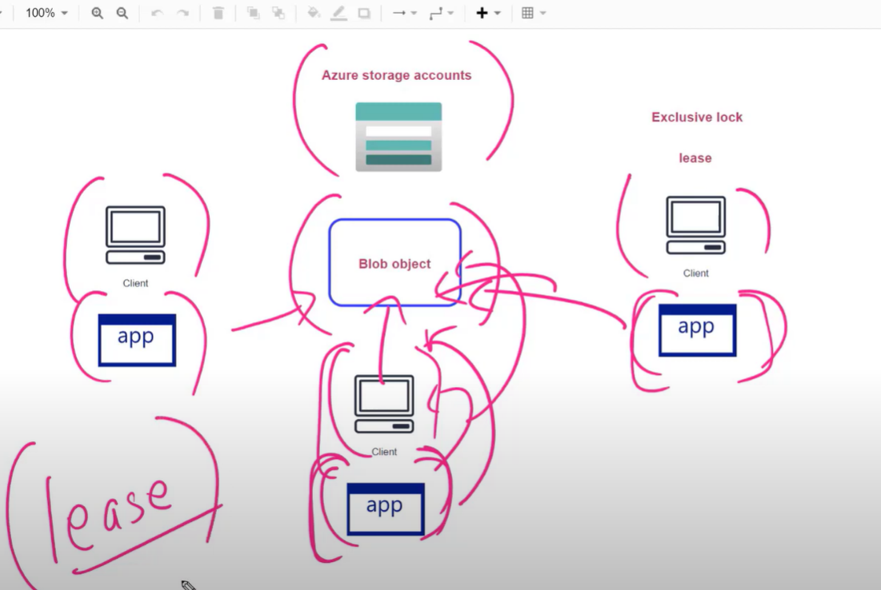

**(you cannot edit , delete blob because its container active lease id , but you can view and download until to release lease)**

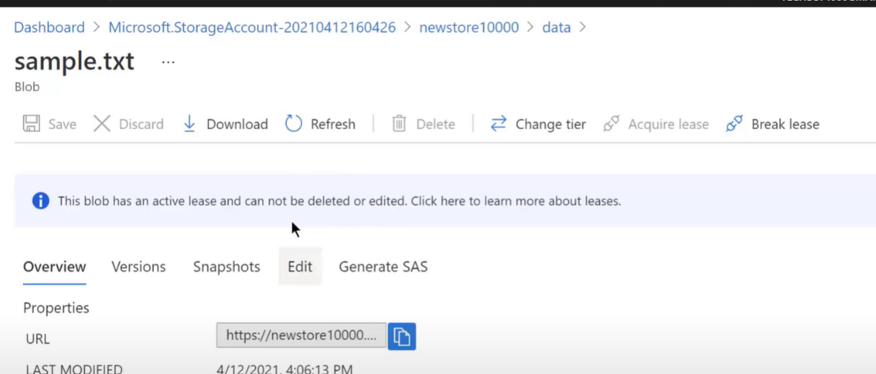

**You can break lease in order to apply update / delete blob**

